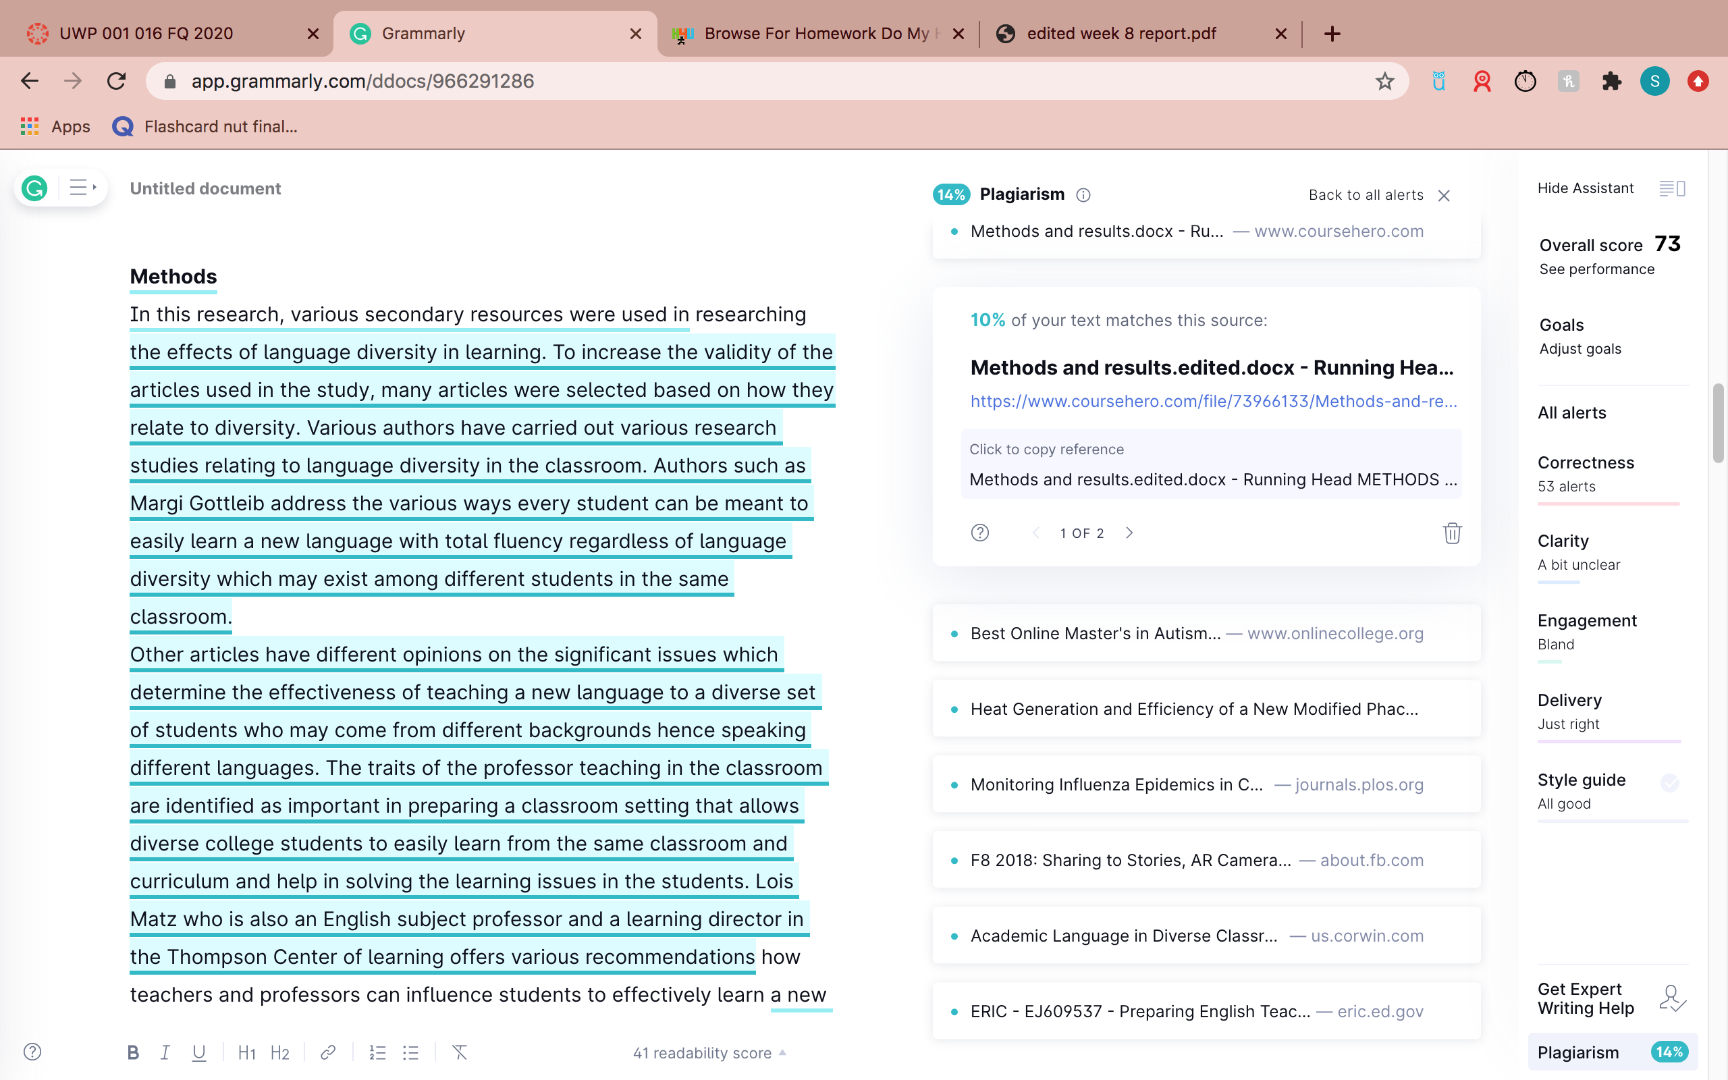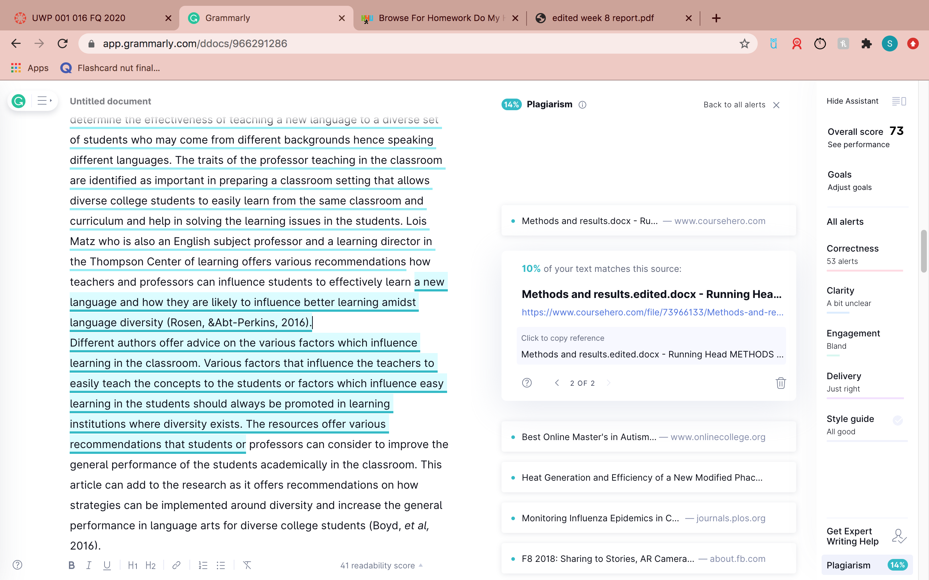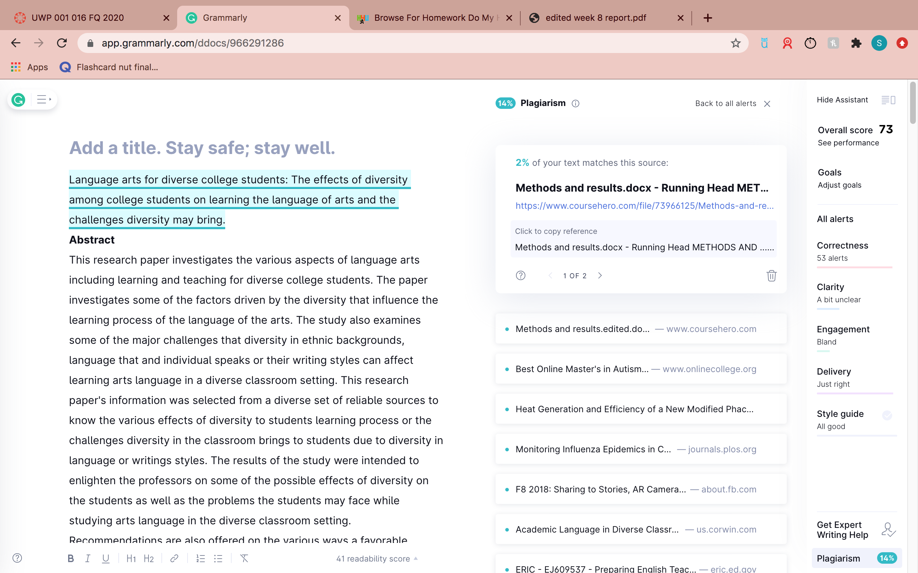

I find that your method and result section are the same thing as the file in the course hero. I think my professor will notice that.
https://www.coursehero.com/file/73966133/Methods-and-resultsediteddocx/

Can you just change all of the words and paraphrase everything in those sections. I just want to play safe, dear. Also, the title is just the same thing. Can you change it and make it similar?

